How to Work with the Cmap Tool

For the BRIDG High-level Concepts Diagram

The purpose of this process is to describe how to use the Cmap Tool to update the BRIDG High-level Concepts Diagram, which is planned to be the default opening diagram in the next release of BRIDG (5.3.1).

1. Download and install the free cmap tool from <https://cmap.ihmc.us/cmaptools/cmaptools-download/>.

* The cmap tool will now be in the IHMC CmapTools folder – see screenshot below.

1. Open the BRIDG High-level Concepts Diagram
   1. The file is available in Github at <https://github.com/CBIIT/bridg-model/blob/master/Technical%20Files/Concept%20Maps/BRIDG%20High%20Level%20Concepts%20V2.cmap>.
   2. As of July 2019, the diagram looks like this:

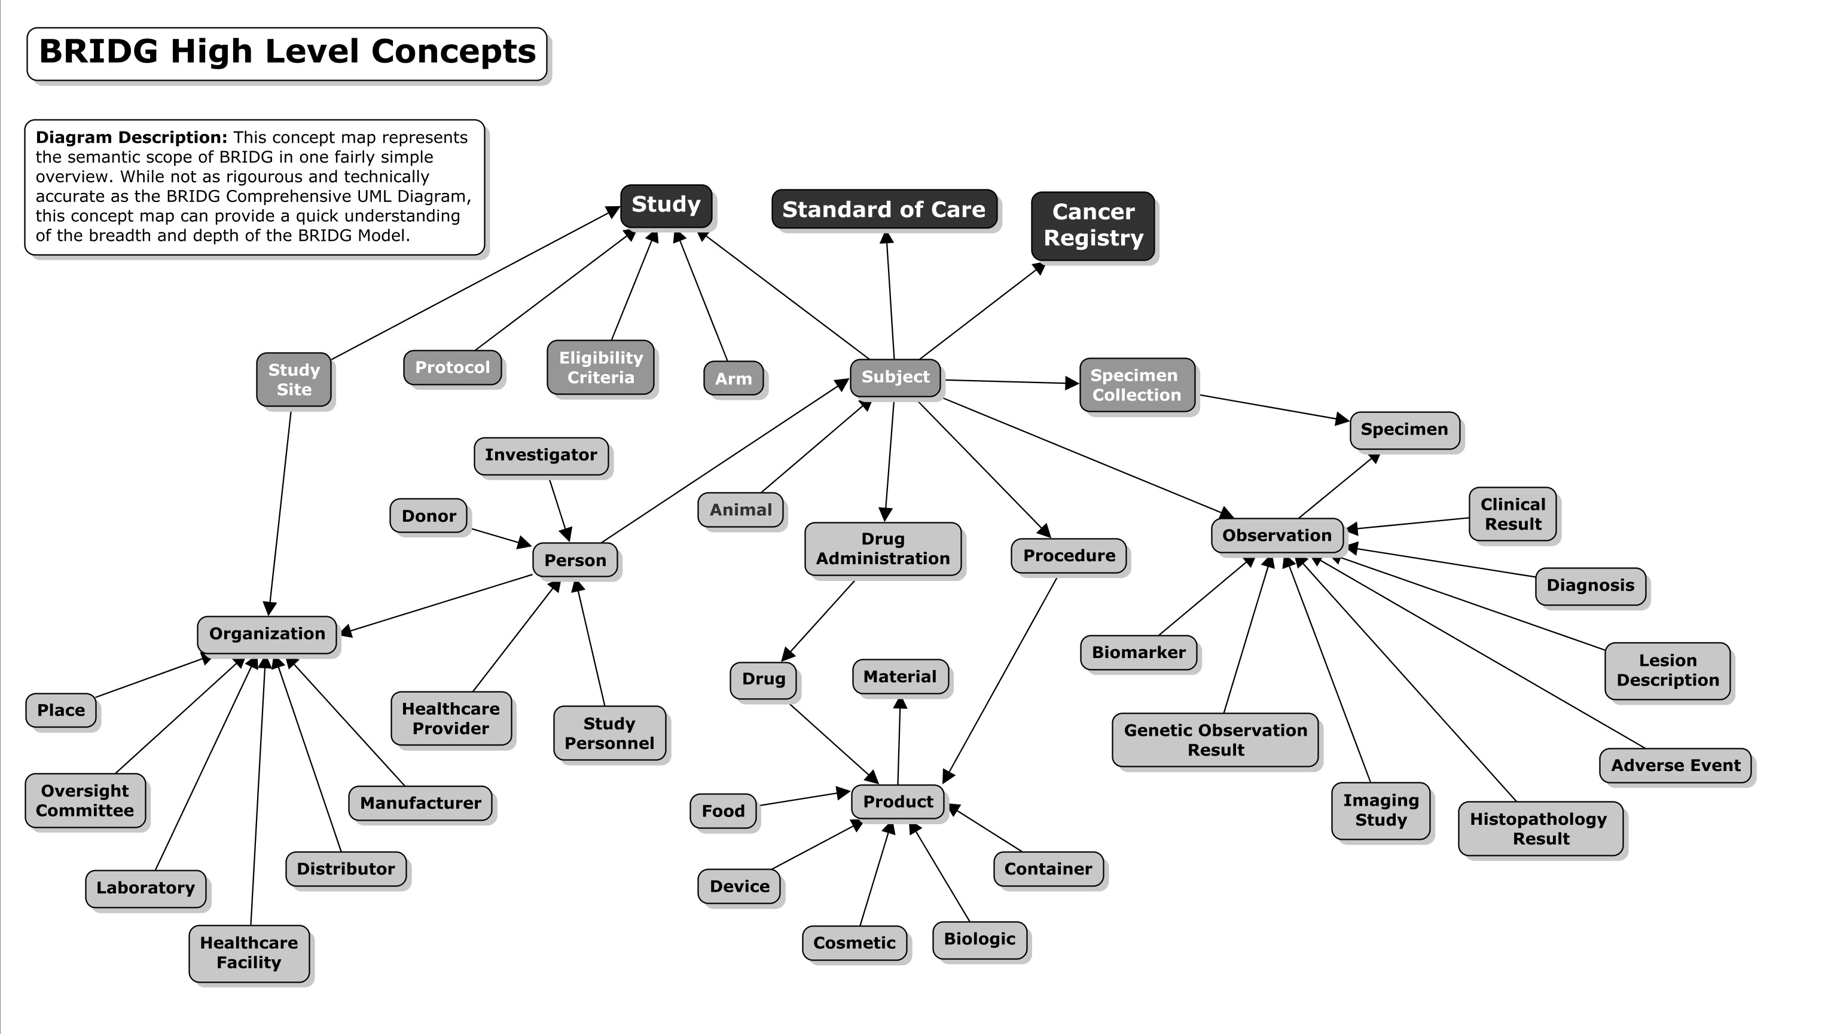

1. Edit the diagram as needed.

* The tool is intuitive and fairly simple to learn.
  + To create a new cmap, select File > New Cmap from the main menu.

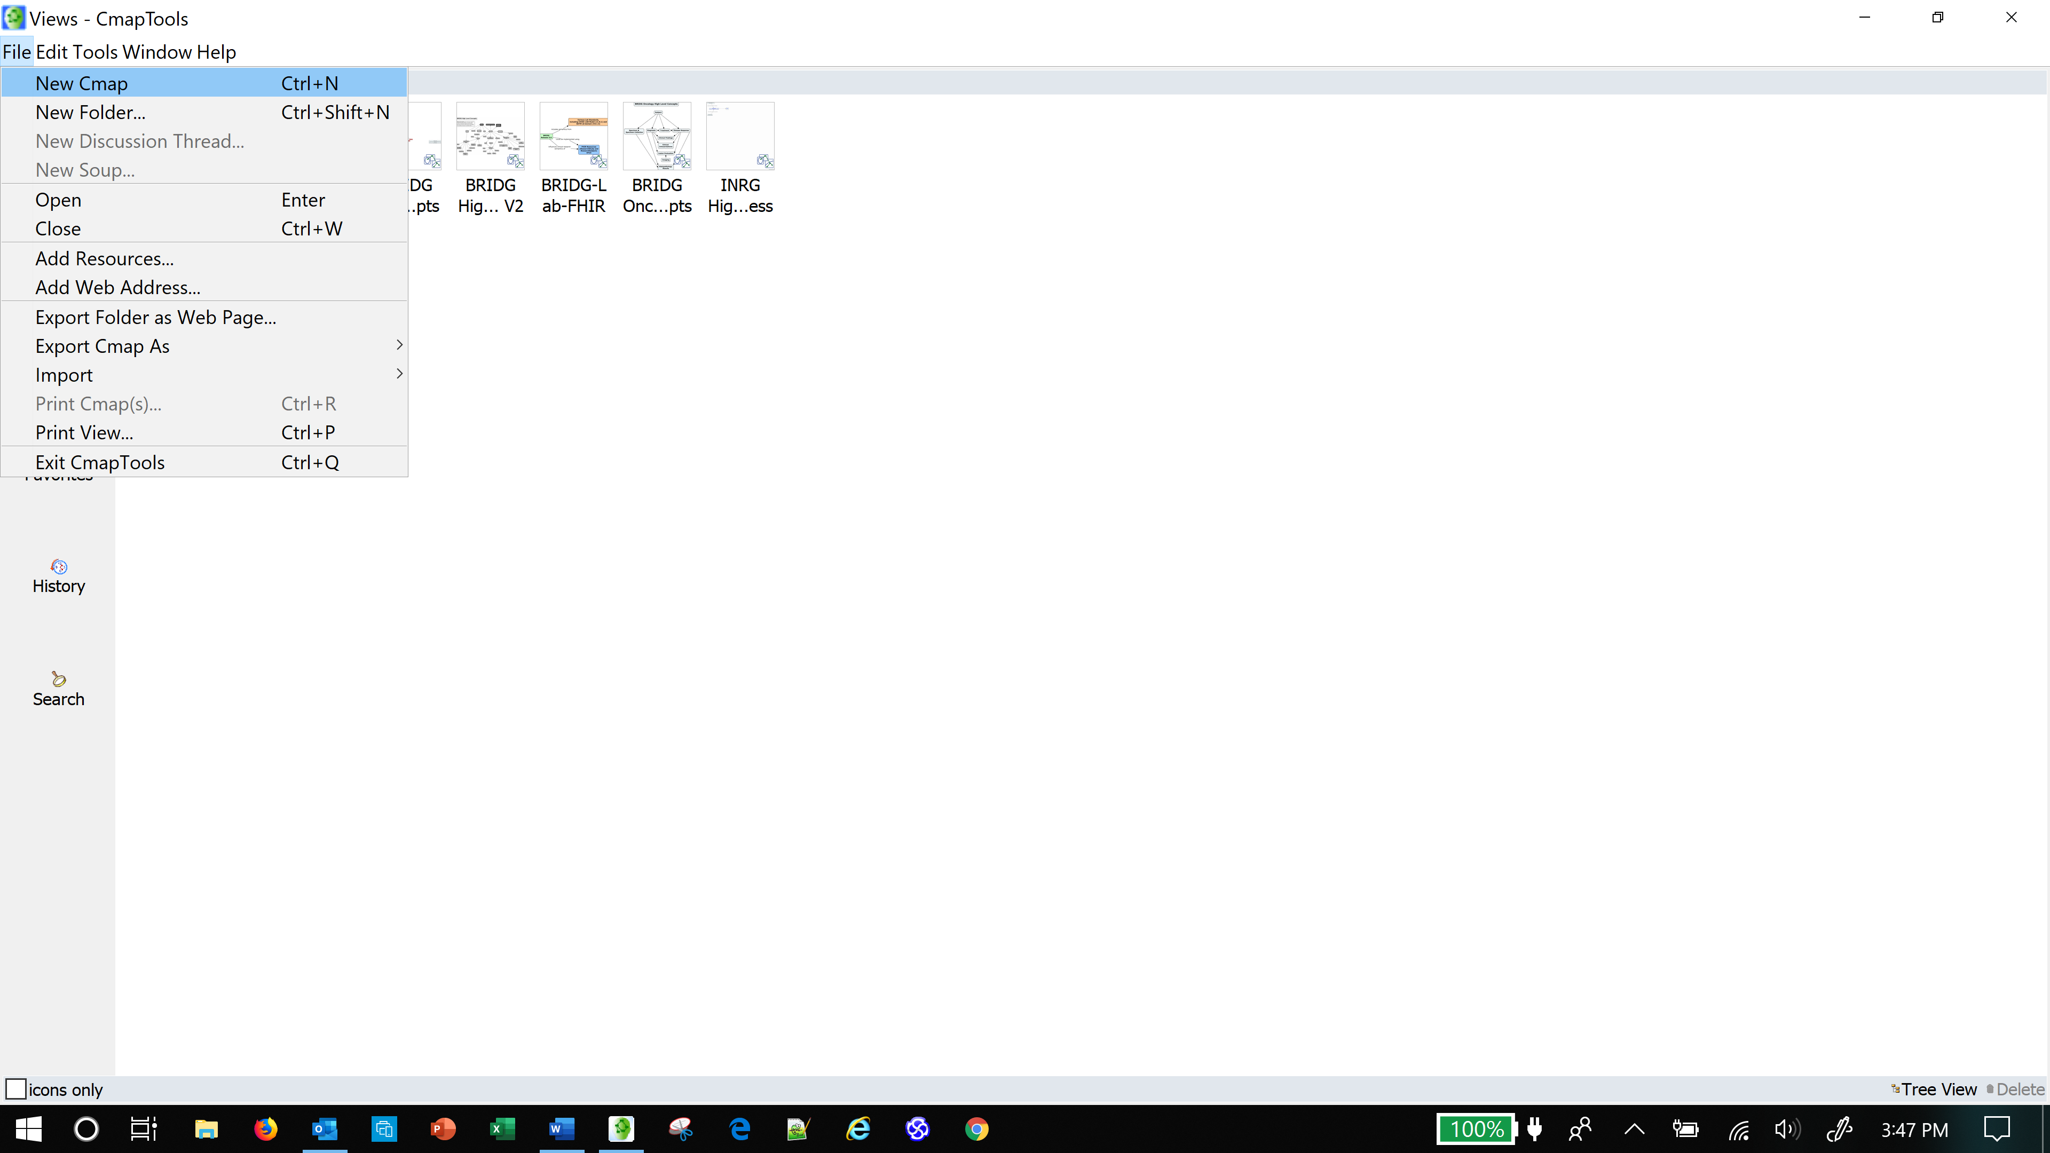

* + To create a new concept, double click in an empty area of the diagram. The tool will display this instruction as shown in the screenshot below.

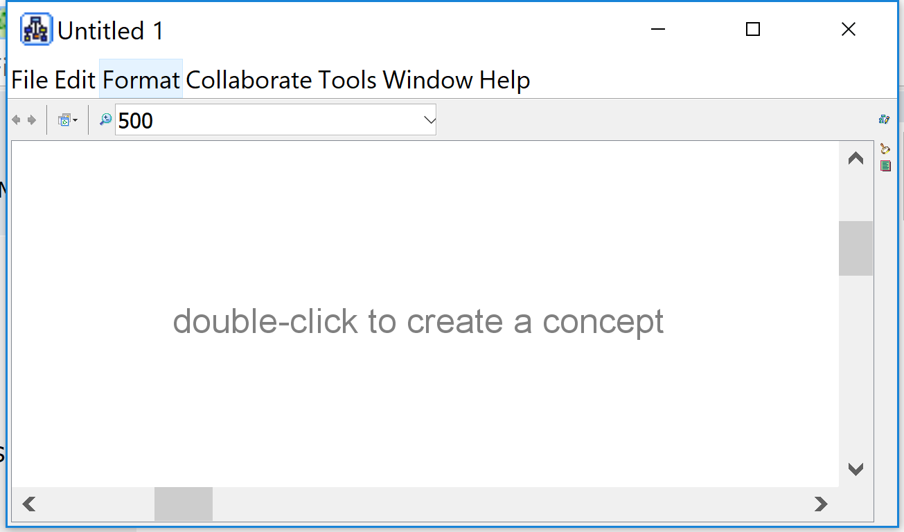

* This diagram uses “link lines” without labels. Cmap defaults to lines with labels. See examples of both in the screenshot below.

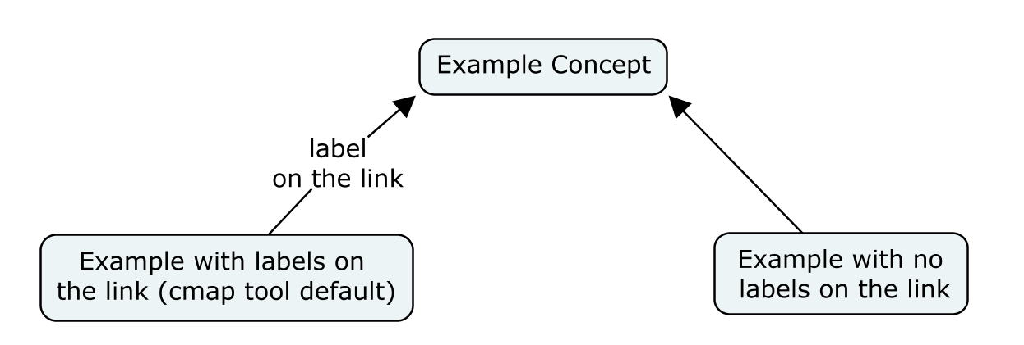

Having a label on the link line is the default. Just drag the link icon to another concept and a label entry box will appear on the link.

To draw a link line with no label, hold down the SHIFT key while dragging the link icon.